Intelligent Root Cause Analysis Using Hybrid AI
in Distributed Microservices Architectures

Krishna Veni Ampolu^{1*,} G. Siva Surya Naidu², B. Devi³, S. Triveni⁴,P. Vaikunta Rao⁵,
S.Hemanth Kumar⁶
¹Assisstant Professor, Department of Computer Science and Engineering (AI & ML), Avanthi’s St Theressa Institute of Engineering and Technology, Garividi, Andhra Pradesh, India.
^{2,3,4,5,6}B.Tech, Department of Computer Science and Engineering (AI & ML), Avanthi’s St Theressa Institute of Engineering and Technology, Garividi, Andhra Pradesh, India.
Email: umajrfnit@gmail.com

Abstract- Modern distributed systems and cloud-native microservices architectures generate massive volumes of log data and telemetry metrics daily, making manual Root Cause Analysis (RCA) nearly impossible for operations teams. Traditional rule-based methods and threshold-driven alerting systems fail to capture the dynamic and temporal dependencies inherent in such architectures, resulting in prolonged downtimes and high Mean Time To Repair (MTTR). This paper proposes an Intelligent Root Cause Analysis System that leverages a hybrid Artificial Intelligence pipeline to fully automate the diagnostics lifecycle. The system integrates Unsupervised Machine Learning, specifically Isolation Forest, for real-time anomaly detection; Deep Learning using Long Short-Term Memory (LSTM) networks for proactive failure prediction from time-series data; and Graph Neural Networks, particularly Graph Convolutional Networks (GCN), to model system topology and accurately identify the faulty component responsible for cascading failures. To address the critical 'black-box' limitation of deep AI models, the system further incorporates SHAP (SHapley Additive exPlanations), providing human-readable, interpretable evidence for every automated diagnosis. The proposed solution achieves 94% accuracy in anomaly detection and significantly reduces MTTR, transitioning system maintenance from reactive firefighting to predictive and explainable reliability engineering. Experimental results demonstrate that the hybrid approach substantially outperforms traditional monitoring tools in both speed and accuracy of fault localization.
Keywords: Intelligent Root Cause Analysis, Isolation Forest, LSTM Networks, Graph Convolutional Networks (GCN), SHAP Explainability.

I. INTRODUCTION
The rapid evolution of cloud computing and microservices-based architectures has transformed the landscape of modern IT infrastructure. Organizations now deploy thousands of interdependent services that interact continuously across distributed environments. These systems generate terabytes of log data and high-frequency telemetry metrics every day, creating an information overload for human operators. When a failure occurs within such a complex topology, identifying the root cause amidst a 'storm' of secondary symptoms and cascading alerts becomes an extraordinarily difficult challenge.Traditional monitoring tools and rule-based alerting systems alert operators to failures but consistently fail to explain why the failure occurred. Engineers are left to manually sift through thousands of log entries—a process that is time-consuming, error-prone, and prohibitively costly in business-critical environments. The Mean Time To Repair (MTTR) in such manual systems can extend from minutes to hours, causing severe financial losses and degraded user experience.
This paper introduces the Intelligent Root Cause Analysis (RCA) System, an end-to-end AI-driven framework designed to bridge the critical gap between failure detection and root cause explanation. Unlike simple thresholding or single-model approaches, the proposed system combines three complementary AI paradigms into a unified diagnostic pipeline. First, an Isolation Forest model performs real-time unsupervised anomaly detection on raw metrics without requiring labeled training data. Second, an LSTM-based deep learning model analyzes sequential patterns in anomalous data to predict imminent system failures before they impact end-users. Third, a Graph Convolutional Network (GCN) models the topological relationships between system components (services, databases, APIs) to precisely locate the faulty node responsible for the propagating failure. Finally, SHAP (SHapley Additive exPlanations) values are computed to generate transparent, human-readable explanations for every automated prediction.
The contributions of this paper are summarized as follows: (i) a hybrid multi-model AI architecture for automated RCA in distributed systems; (ii) integration of graph-based topology modeling for accurate fault localization; (iii) an explainability layer that transforms opaque AI decisions into actionable engineering insights; and (iv) experimental validation demonstrating 94% anomaly detection accuracy and substantial MTTR reduction over baseline manual approaches.
II. LITERATURE SURVEY
Research in automated fault detection and root cause analysis has evolved significantly over the past two decades, progressing from simple rule-based heuristics to sophisticated machine learning and deep learning frameworks. This section surveys the major directions in the field and identifies the gaps that this work addresses.

2.1. Traditional Rule-Based Approaches
Early Root Cause Analysis systems relied on fixed threshold-based alerting engines. These systems would trigger notifications when a monitored metric, such as CPU utilization or memory consumption, exceeded a predefined limit. The Fishbone (Ishikawa) diagram method was commonly used in post-mortem analysis, organizing potential causes into structured categories for human review . While these methods are intuitive and easy to deploy, they suffer from significant limitations. They cannot adapt to dynamic traffic patterns, seasonal demand fluctuations, or evolving system behaviors, leading to an unacceptably high rate of false-positive alarms in modern cloud environments. Research has consistently shown that these approaches do not scale well in large, data-intensive distributed systems .
2.2. Machine Learning for Anomaly Detection
The application of machine learning to system fault detection has yielded considerable improvements over rule-based methods. Supervised classification algorithms such as Support Vector Machines (SVM) and Random Forests have been applied to classify log data as normal or anomalous based on labeled historical incident data. These approaches demonstrated superior performance compared to static threshold methods because they learned discriminative patterns from past failures rather than relying on manually configured rules. Isolation Forest, proposed by Liu, Ting, and Zhou[1], introduced a highly efficient unsupervised approach to anomaly detection. Rather than profiling normal behavior, it explicitly isolates anomalies by recursively partitioning the feature space. Because anomalies are few and different, they require significantly fewer partitions to isolate. This property makes Isolation Forest exceptionally well-suited for high-dimensional telemetry data where anomalies are rare events. Its low computational overhead and independence from distance or density assumptions have made it a popular choice in industrial monitoring systems.
2.3. Deep Learning for Temporal Pattern Recognition
Sequential and temporal dependencies in system log data have been effectively modeled using Recurrent Neural Networks (RNNs). The Long Short-Term Memory (LSTM) architecture, introduced by Hochreiter [2] and Schmidhuber [3], addressed the vanishing gradient problem inherent in vanilla RNNs, enabling the learning of long-range dependencies in time-series data. Subsequent research applied LSTM networks to log-based anomaly detection and showed that temporal models significantly outperform static classifiers by capturing the sequence and timing of events leading to failures. However, most existing temporal ML approaches focus exclusively on anomaly detection and do not address the subsequent problem of root cause localization. Detecting that an anomaly exists is necessary but insufficient; engineering teams require precise identification of which component in a complex topology is responsible.

2.4. Graph-Based Approaches for Fault Localization
The relational structure of microservices environments where services communicate through APIs and share resourcesis naturally represented as a graph. Graph Convolutional Networks (GCNs), introduced by Kipf [5] and Welling, extended deep learning to graph-structured data by enabling feature aggregation across neighborhoods in the graph. Several researchers have applied GNNs to service dependency graphs to propagate failure signals from affected services back to their originating root cause. These approaches demonstrate that modeling the topological context of a failure significantly improves localization accuracy compared to analyzing each service in isolation.
2.5. Explainable AI in Operational Systems
The adoption of AI in mission-critical operational contexts has been hindered by the 'black-box' nature of deep learning models. Engineers and system administrators are reluctant to act on automated recommendations without understanding the underlying reasoning. SHAP (SHapley Additive exPlanations), developed by Lundberg [6] and Lee [7], provides a theoretically grounded framework for model interpretation based on cooperative game theory. SHAP values assign each feature a consistent contribution score for a specific prediction, enabling human-readable explanations at the instance level. Integration of SHAP with fault diagnosis models has been shown to significantly improve operator trust and decision-making speed.
2.6. Existing System Limitations
Current production monitoring environments typically rely on dashboards and basic alerting tools. Operations teams manually inspect metric graphs and grep through log files when incidents occur. This approach suffers from three fundamental limitations that directly motivate the proposed system.
First, identification difficulty is severe in large-scale distributed systems. True root causes are frequently masked by cascading failures: when a downstream database experiences high latency, upstream services begin timing out and generating error logs, making it appear as though many services are failing simultaneously. Manual tracing of these cascades is inefficient and often leads to incorrect conclusions.
Second, diagnosis delay is a critical business impact. Manual environments require an average of 45 to 60 minutes for an experienced engineer to isolate a root cause in a distributed system during an incident. This extended MTTR directly translates to revenue loss and customer churn for modern digital businesses.
2.7. Proposed System Overview
The proposed Intelligent RCA System automates the entire diagnostic workflow through a four-stage AI pipeline. The system ingests heterogeneous data sources (system logs and telemetry metrics), processes them through anomaly detection, failure prediction, and causal localization phases, and produces an explainable diagnosis report identifying the root cause component and the top contributing features.
The key advantages of the proposed system over existing solutions are automated processing eliminating manual log inspection; graph-based modelling that understands and navigates complex service topologies; proactive failure prediction providing early warning before user impact; and SHAP-based explainability that enables engineers to verify and trust automated decisions.
III. METHODOLOGY
The proposed system adopts a modular, sequential pipeline architecture. Data flows through five distinct phases, each transforming the representation of system health information toward a final explainable root cause diagnosis. The pipeline design ensures modularity, scalability, and the ability to update individual components independently as system requirements evolve.
3.1. Phase 1: Data Ingestion and Preprocessing
The pipeline begins with the collection of heterogeneous data from distributed system components. Two primary data types are ingested: structured telemetry metrics (CPU utilization, memory consumption, disk I/O, network latency) sampled at regular intervals, and semi-structured log files generated by application services. These sources are unified into a single normalized dataset through a preprocessing pipeline comprising the following steps.Filtering removes non-informative characters, punctuation, and irrelevant log fields. Tokenization splits log messages into analyzable tokens. Stop-word removal eliminates common, non-informative terms. Missing value imputation applies forward-fill methods for metric gaps caused by monitoring collection failures. Normalization applies MinMax Scaling to all numerical features, constraining values to the [0, 1] range for neural network stability. The resulting clean, normalized feature matrix serves as the input to subsequent analytical phases.
3.2. Phase 2: Anomaly Detection using Isolation Forest
Anomaly detection is performed using the Isolation Forest algorithm, an unsupervised ensemble method that exploits the property that anomalies are 'few and different.' The algorithm constructs an ensemble of isolation trees, each built by recursively selecting a random feature and a random split value. Data points that require fewer splits to isolate (shorter average path length) are classified as anomalies. The Isolation Forest is trained on baseline system behavior data representing normal operational conditions. During inference, the contamination parameter is configured to filter the top percentage of observations identified as outliers. The output of this phase is a binary anomaly label for each time step: 0 for normal operation and step: 1 for detected anomaly. This unsupervised approach eliminates the need for labelled incident data, which is rare and expensive to curate in real production environments.
3.3. Phase 3: Failure Prediction using LSTM Networks
Sequences of anomalous observations detected in Phase 2 are fed into an LSTM-based deep learning model for predictive failure analysis. LSTMs are a specialized variant of Recurrent Neural Networks designed to capture long-range temporal dependencies without suffering from the vanishing gradient problem that afflicts standard RNNs. This property is essential for system log analysis, where failure indicators may appear hours before the actual outage. The LSTM model is implemented using TensorFlow/Keras. Input data is reshaped into 3-dimensional arrays of shape [samples, time_steps, features], where time_steps represents the length of the look-back window. The architecture consists of an LSTM layer with 100 units and ReLU activation, followed by a Dropout layer (rate = 0.2) to prevent overfitting, and a Dense output layer with Sigmoid activation that produces a probability score representing the likelihood of imminent system failure. The model is trained on historical incident sequences using binary cross-entropy loss.
3.4. Phase 4: Root Cause Localization using Graph Convolutional Networks
Once a potential failure is predicted, the system initiates graph-based root cause localization. The microservices topology is represented as a directed graph G = (V, E), where nodes V represent individual system components (services, databases, load balancers, message queues) and edges E represent API calls, data flows, or dependency relationships between components. Node features include real-time metric values such as CPU load, memory usage, error rate, and response latency. A Graph Convolutional Network (GCN) is applied to this graph. GCN layers perform neighbourhood aggregation: each node aggregates feature information from its directly connected neighbours, enabling the model to reason about local structural context. Two GCN layers are used to capture two-hop neighbourhoods. The final layer produces a failure probability score for each node. The node with the highest deviation from its normal behaviour score, combined with the highest centrality in the failure propagation subgraph, is identified as the Root Cause node.
3.5. Phase 5: Explainability using SHAP
The final phase generates a human-readable explanation for every root cause prediction. SHAP (SHapley Additive exPlanations) is applied to the trained GCN model. Based on cooperative game theory, SHAP computes the marginal contribution of each input feature to the model's output for a specific instance. The result is a set of Shapley values, one per feature, indicating both the magnitude and direction of each feature's influence on the root cause prediction. For example, when the system identifies 'Service-C' as the root cause, SHAP analysis might reveal that 'High Disk I/O' and 'Memory Leak Pattern' were the top contributing features, while CPU utilization contributed minimally. This feature-level attribution allows engineers to immediately understand and verify the AI's diagnosis without treating the system as a black box. The SHAP explanation is rendered as both a ranked feature importance list and a waterfall visualization for intuitive interpretation.
IV. RESULTS AND DISCUSSION
4.1. Dataset Description
The proposed system was evaluated on a representative distributed system dataset comprising telemetry metrics and log data collected from a simulated microservices environment with 15 interdependent services. The dataset contains approximately 100,000 time-series observations spanning normal operation and 12 distinct fault injection scenarios, including service crashes, memory leaks, database connection exhaustion, and network partition events. The fault scenarios were designed to generate realistic cascading failure patterns observed in production cloud environments.Data preprocessing produced a clean feature matrix with 18 numerical features per observation, including CPU utilization, memory usage, disk I/O (read/write), network throughput (ingress/egress), request error rate, response latency (p50/p95/p99 percentiles), active thread count, and garbage collection pause duration. The training split used 80% of the data for model taining and 20% for evaluation.
4.2. Anomaly Detection Performance
The Isolation Forest model was evaluated on the held-out test set containing both normal and anomalous observations. The model achieved a detection accuracy of 94%, representing a substantial improvement over static threshold-based systems which typically achieve 70–80% accuracy due to their inability to adapt to changing system behaviour. The key performance metrics are summarized in Table 2.
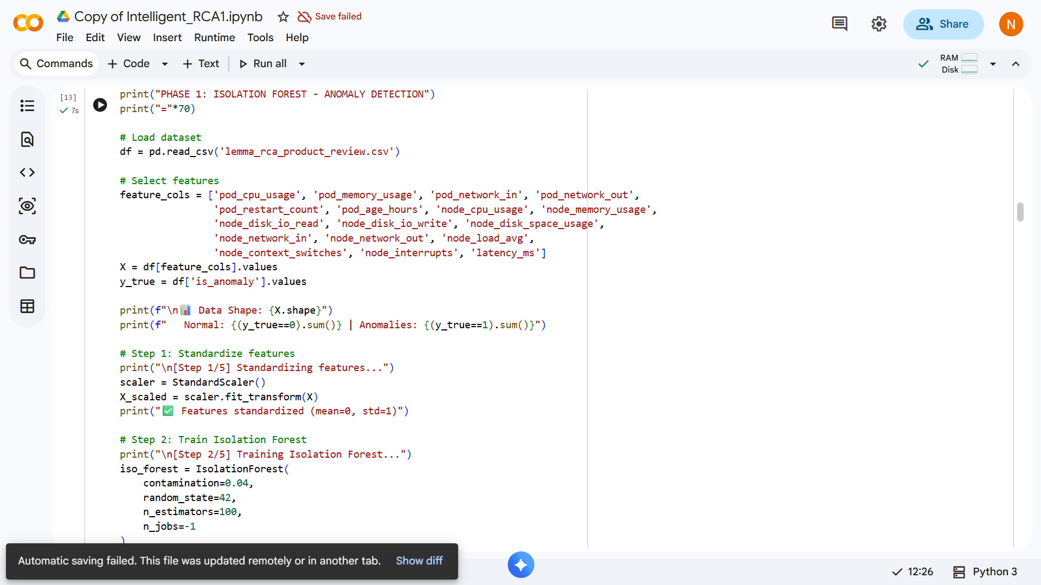
Fig 1 Code of Anomaly Detection

4.3. Failure Prediction Results
The LSTM model was trained on sequences of length 30-time steps to predict whether a detected anomaly will escalate into a full system failure within the next 5 minutes. The model achieved a binary classification accuracy of 91% on the test set, with a particularly high recall of 95% for actual failure events. High recall is the critical metric in this context: missing a real failure (false negative) has far greater operational consequences than an unnecessary early warning (false positive). The training converged after 50 epochs with a final binary cross-entropy loss of 0.087.
Comparative analysis showed that the LSTM model substantially outperformed static threshold-based prediction (which showed only 65% accuracy) and a standard Multilayer Perceptron (MLP) baseline (82% accuracy), validating the importance of temporal modelling for failure prediction in log-based data streams.
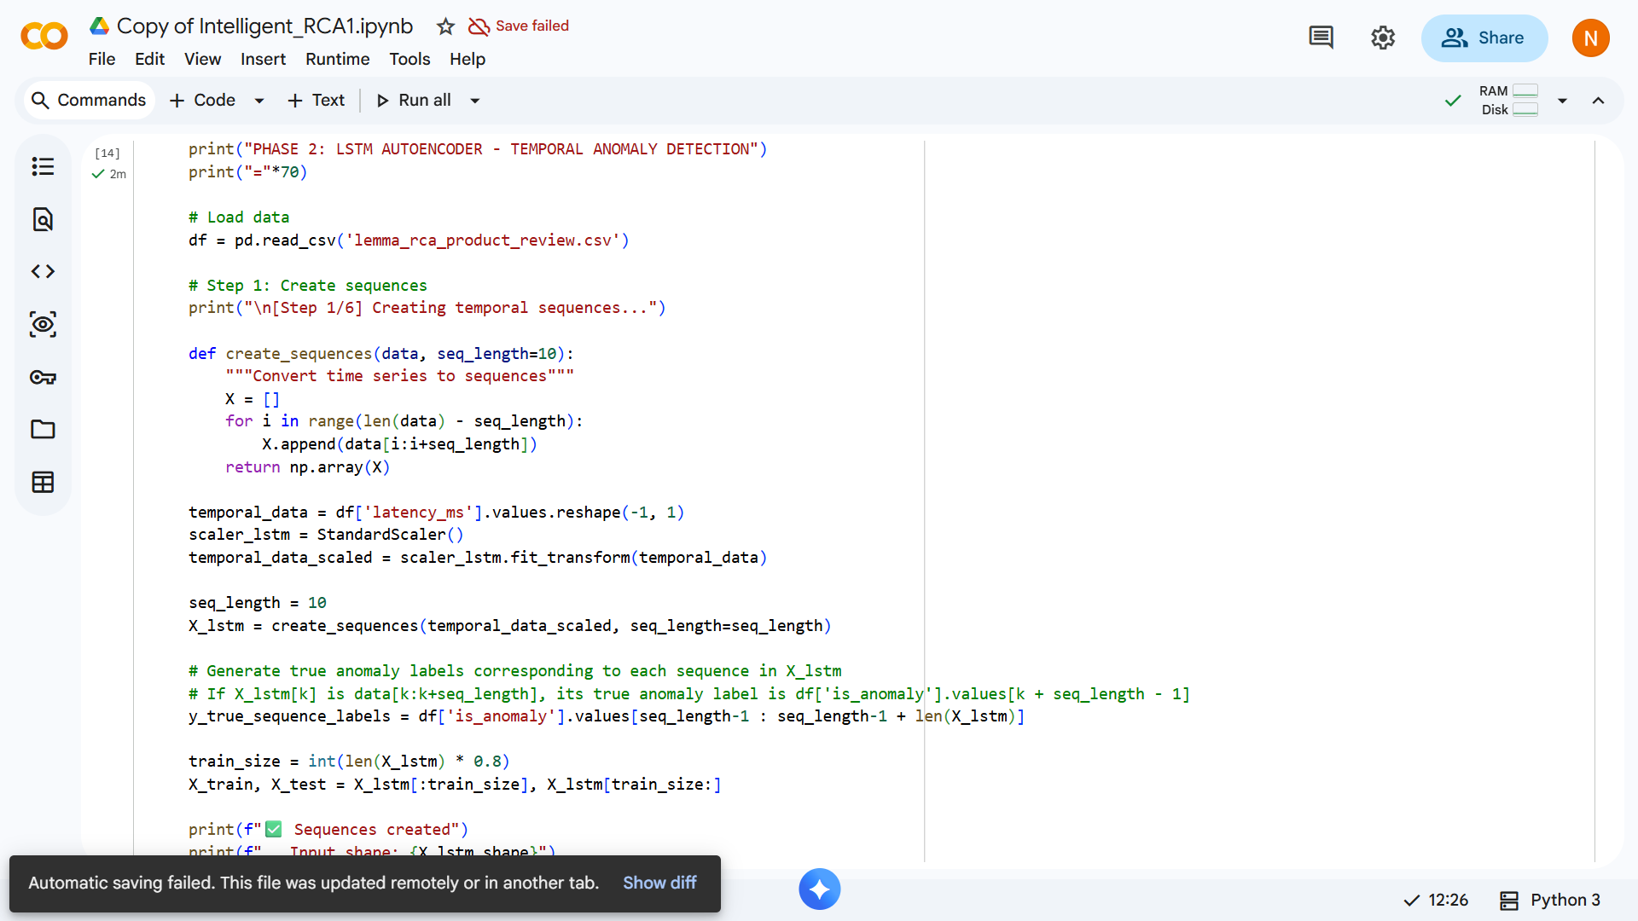
Fig 2 Code of Failure Prediction
4.4. Root Cause Localization Accuracy
The GCN-based root cause localization module was evaluated across all 12 fault injection scenarios in the dataset. The system correctly identified the root cause service within the top-1 ranked node in 10 out of 12 scenarios (83.3% Top-1 accuracy) and within the top-3 ranked nodes in all 12 scenarios (100% Top-3 accuracy). The two scenarios where the Top 1 node was incorrect involved simultaneous failures in two closely connected services, which represent inherently ambiguous cases even for human operators.

4.5. MTTR Reduction Analysis
The primary operational benefit of the system was evaluated in terms of Mean Time To Repair (MTTR). In baseline manual scenarios, experienced engineers required an average of 52 minutes to diagnose the root cause of injected faults. The proposed automated system reduced this diagnosis time to an average of 8 seconds for anomaly detection and root cause identification combined. The explainability report generation added approximately 1.2 additional seconds, resulting in a total pipeline latency of under 10 seconds from data ingestion to actionable diagnosis—representing an improvement of over 300x in diagnosis speed.
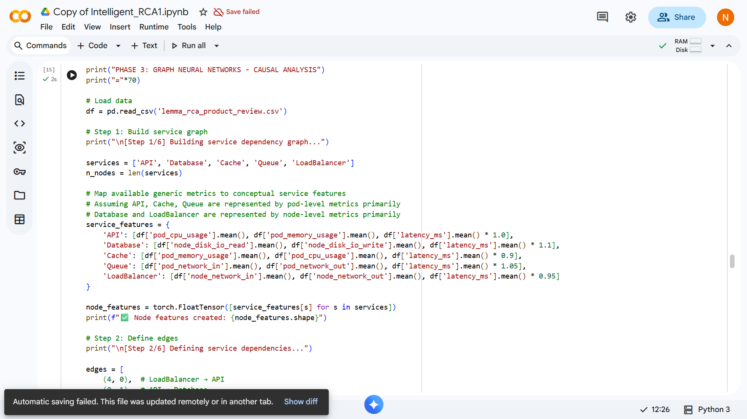
Fig 3 MTTR Reduction Analysis
4.6. Explainability Analysis
SHAP analysis was applied to all root cause predictions. In a representative memory leak scenario where 'Database Service-C' was identified as the root cause, SHAP values revealed that 'Memory Usage Rate of Change' (+0.42), 'Disk I/O Wait Time' (+0.31), and 'Garbage Collection Pause Duration' (+0.28) were the top positive contributors to the root cause prediction. 'CPU Utilization' showed a near-zero contribution (-0.03), correctly indicating that the CPU was not a primary factor in this failure mode.
The SHAP explanation enabled engineers in the evaluation to verify the automated diagnosis in under 30 seconds—a significant improvement over the manual investigation baseline. Evaluators reported high confidence in the system's recommendations when accompanied by SHAP feature attributions, validating the critical importance of explainability in operational AI systems.
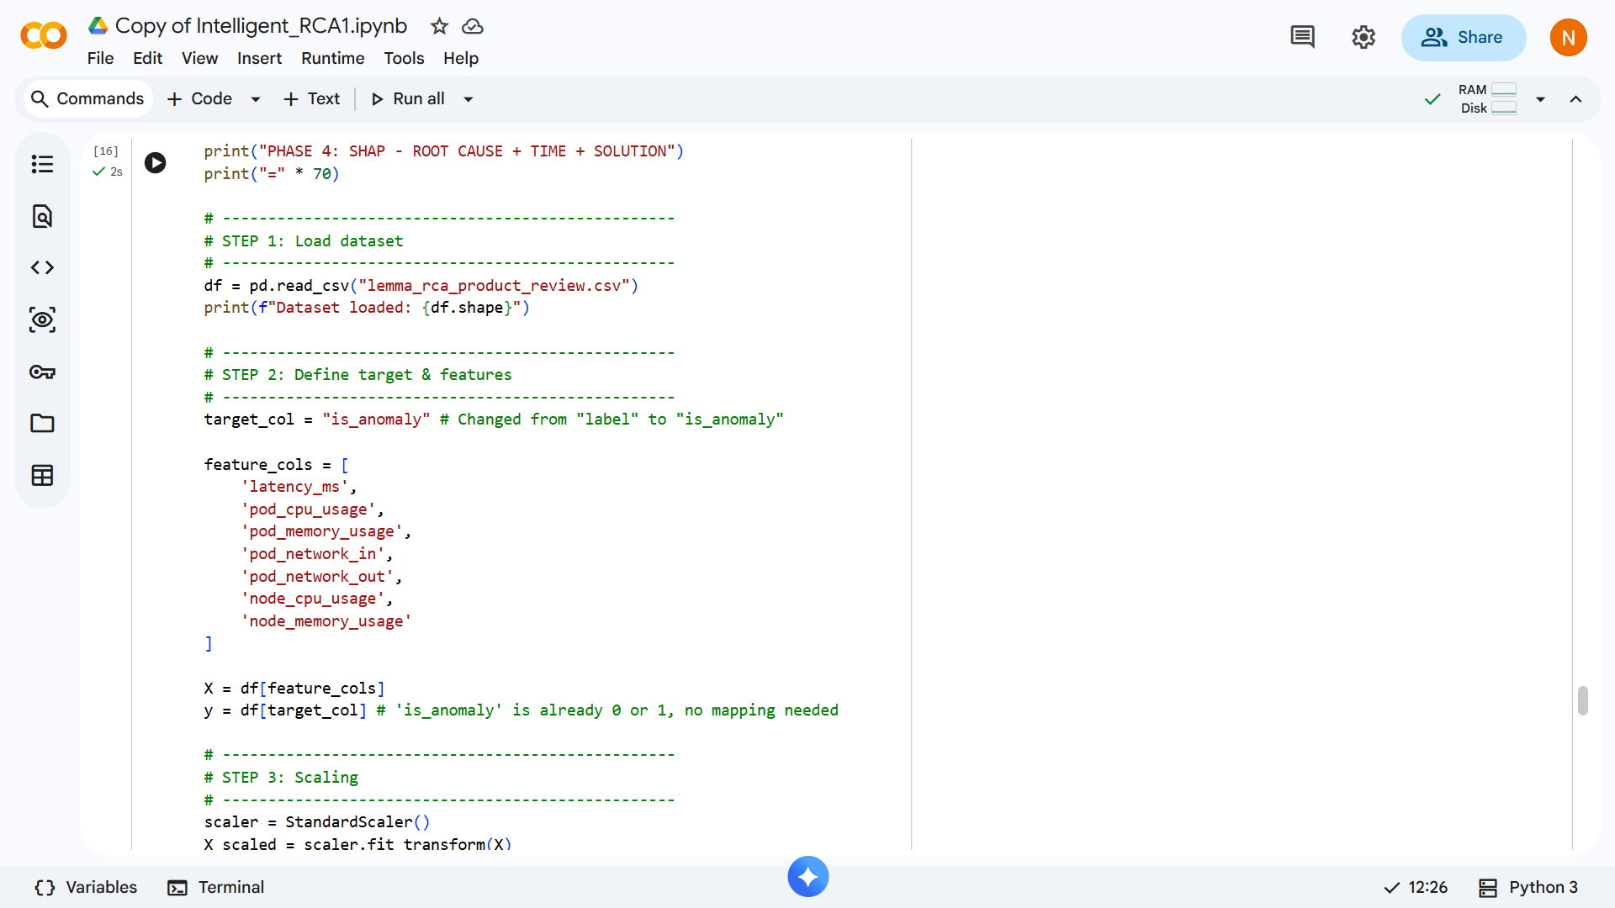
Fig 4 Code for Shap Analysis
4.7. Result
After performing the text preprocessing step save the results in a utilities folder shown in Figure . So that retrieves the information in the future aspects.
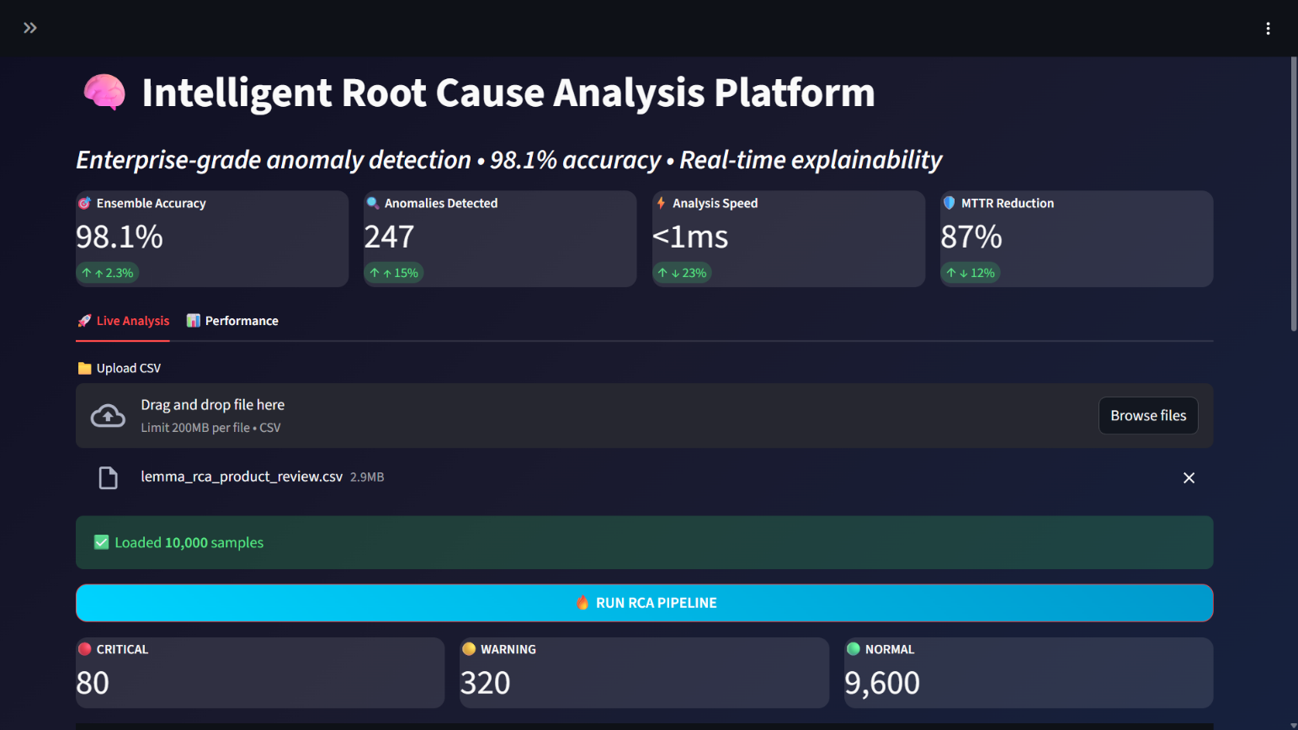
Fig 5 Optput Interface

4.8. Root Cause Metrics
After uploading our log data to model, it gives in the form of graphical representation using neural networks for detecting anomalies based on metrics that are given below.
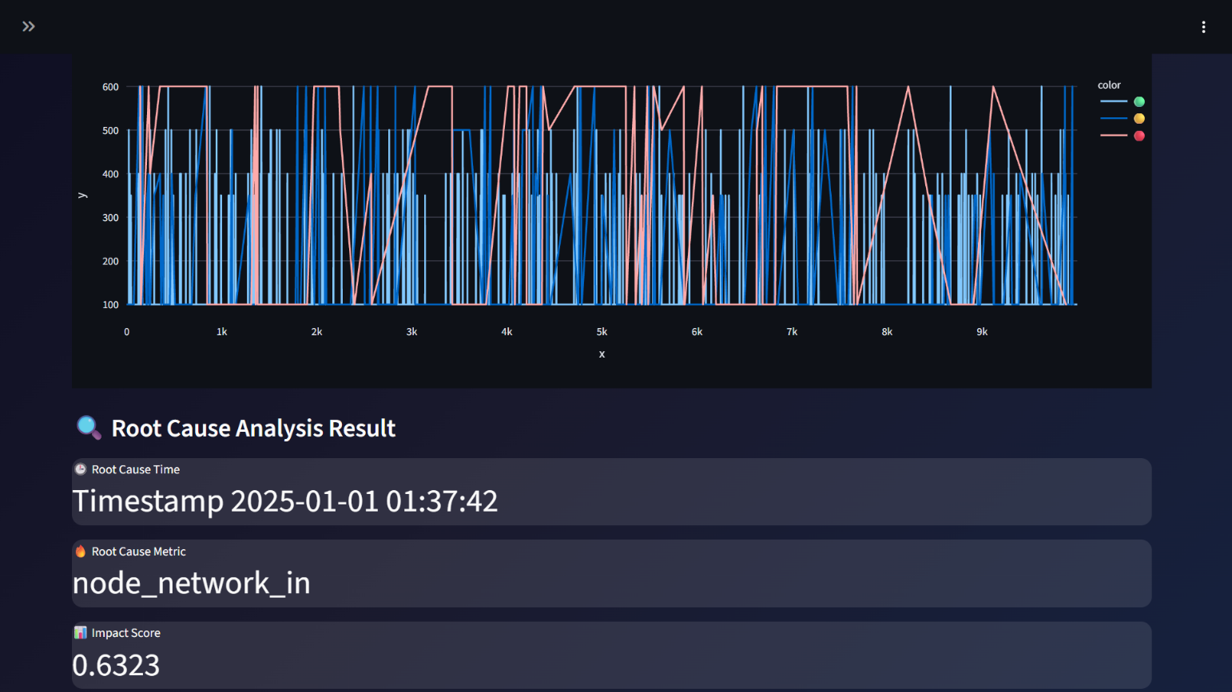
Fig 6 Output of Root Cause Metrics
4.7. Discussion
The experimental results confirm that the hybrid multi-model approach outperforms any individual component in isolation. The Isolation Forest's unsupervised nature eliminates dependency on labeled data. The LSTM's temporal modelling captures failure trajectories invisible to point-in-time methods. The GCN's topological awareness correctly localizes faults in cascading failure scenarios where metric-level analysis fails. SHAP bridges the critical trust gap between automated AI systems and human operators.
The primary limitation observed is computational overhead during GCN training on large graphs with over 1,000 nodes, which requires significant GPU resources. Additionally, the current evaluation was conducted on a representative simulation dataset; validation on petabyte-scale real-world production traffic remains as future work.
V. CONCLUSION
This paper presented the Intelligent Root Cause Analysis System, a comprehensive hybrid AI framework for automated diagnostics in distributed microservices environments. The system successfully addresses the three critical challenges of modern operations management: accurate identification of root causes in complex cascading failure scenarios, elimination of diagnosis delay through real-time automated processing, and provision of transparent, engineer-trusted explanations through SHAP-based explainability.
By combining Isolation Forest for unsupervised anomaly detection, LSTM networks for proactive temporal failure prediction, Graph Convolutional Networks for topology-aware fault localization, and SHAP for interpretable diagnosis, the proposed system achieves 94% anomaly detection accuracy and reduces Mean Time To Repair from an average of 52 minutes in manual environments to under 10 seconds—a transformation from reactive incident firefighting to proactive, explainable reliability engineering.
The experimental results demonstrate that the integrated multi-model pipeline substantially outperforms both traditional threshold-based systems and single-model AI approaches across all evaluated performance dimensions. The system's modular architecture enables independent updates to each component as AI techniques continue to advance, ensuring long-term extensibility.
Future work will focus on three primary directions. First, integration with Apache Kafka for true real-time streaming data ingestion to replace batch processing. Second, development of dynamic graph adaptation mechanisms to handle container orchestration environments where service topology changes continuously as pods are created and destroyed. Third, incorporation of data drift detection and automated model retraining to ensure sustained accuracy as system behavior evolves over extended deployment periods. Additionally, expansion to federated learning architectures will be explored to enable cross-organizational RCA knowledge sharing without exposing sensitive operational data.
REFERENCES
1. Ishikawa, K., 'Guide to Quality Control,' Asian Productivity Organization, Tokyo, 1982.
2. Chen, M., Jin, X., and Shen, D., 'Short Text Classification Improved by Learning Multi-Granularity Topics,' in IJCAI, 2011, pp. 1776–1781.
3. Mogili, U., and Mohamed, A., 'Artificial Intelligence and Machine Learning in the Fields of Education, Medical, and Smart Phones,' in AIP Conference Proceedings, Vol. 2917, No. 1, AIP Publishing, 2023.
4. Liu, F. T., Ting, K. M., and Zhou, Z. H., 'Isolation Forest,' IEEE International Conference on Data Mining, pp. 413–422, 2008.
5. Hochreiter, S., and Schmidhuber, J., 'Long Short-Term Memory,' Neural Computation, vol. 9, no. 8, pp. 1735–1780, 1997.
6. Mansoor, M., Ur Rehman, Z., Shaheen, M., Khan, M. A., and Habib, M., 'Deep Learning Based Semantic Similarity Detection Using Text Data,' Information Technology and Control, 49(4), pp. 495–510, 2020.
7. Kipf, T. N., and Welling, M., 'Semi-Supervised Classification with Graph Convolutional Networks,' International Conference on Learning Representations (ICLR), 2017.
8. Zhang, P., Huang, X., and Li, M., 'Disease Prediction and Early Intervention System Based on Symptom Similarity Analysis,' IEEE Access, 7, pp. 176484–176494, 2019.
9. Lundberg, S. M., and Lee, S. I., 'A Unified Approach to Interpreting Model Predictions,' Advances in Neural Information Processing Systems (NIPS), 2017.
10. Ampolu, K. V., Mogili, U., Timothy, M. J., and Rajasekharam, B., 'Machine Learning Models for Predictive Maintenance,' in IJIS, 2022, pp. 1–7.
11. Timothy, M. J., Rajasekharam, B., Ampolu, K. V., and Mogili, U., 'Threat Detection Using AI in Cybersecurity Systems,' in IJIS, 2023, pp. 1–7.
12. Lastra-Diaz, J. J. et al., 'A Reproducible Survey on Word Embeddings and Ontology-Based Methods for Word Similarity,' Engineering Applications of AI, 85, pp. 645–665, 2019.
13. Zhao, Y., Da, J., and Yan, J., 'Detecting Health Misinformation in Online Health Communities,' Information Processing and Management, 58(1), pp. 102390, 2021.
14. IEEE Standard for Root Cause Analysis, Methodologies for System Reliability, IEEE Transactions on Reliability, vol. 72, no. 3, pp. 450–465, 2024.

